Demand Planning Based on Reorder Point/Build Point
Reorder Point: A reorder point is a specific level at which your stock needs to be replenished. In other words, it tells you when to place an order so you won’t run out of stock. Knowing when to order more stock is important. If you order when you still have a lot of stock on hand, it will lead to extra stockpiling, which will increase your holding costs. If you order when you have zero stock on hand, you’ll be unable to make sales for as long as it takes to receive the order.
Build Point: A Build point is a specific level at which your assembly item stock needs to be replenished. In other words, it tells you when to place a work order so you won’t run out of stock. Knowing when to create work orders is important. If you create work orders when you still have a lot of stock on hand, it will lead to extra stockpiling, which will increase your holding costs. If you order when you have zero stock on hand, you’ll be unable to make sales for as long as it takes to create the work order.
Reorder Point selection for Inventory Item:
Step 1: Inventory Item List: Navigate to Lists -> Accounting -> Items
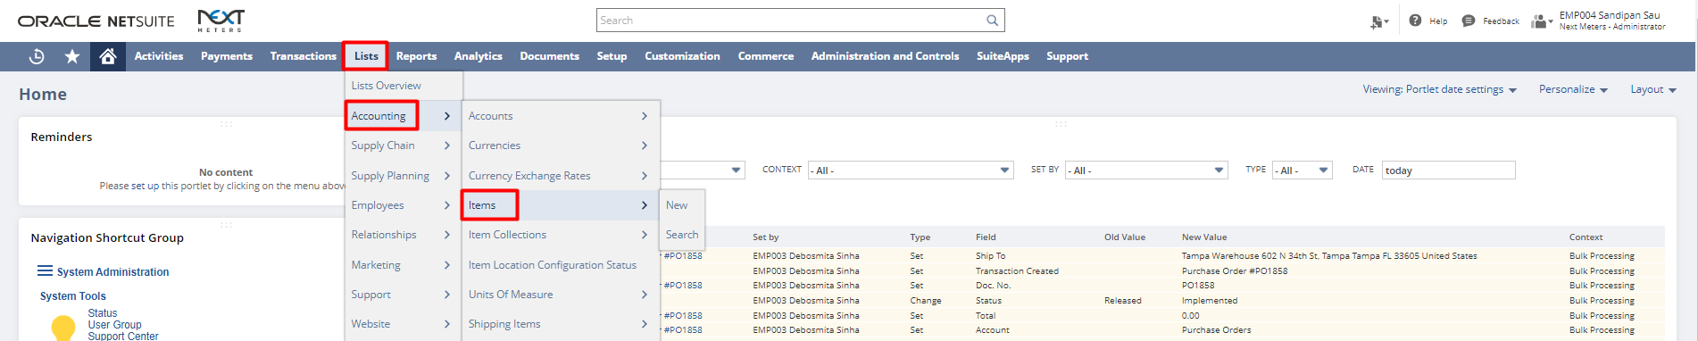
We are taking inventory NCSS-TRSF-001 as an example here.
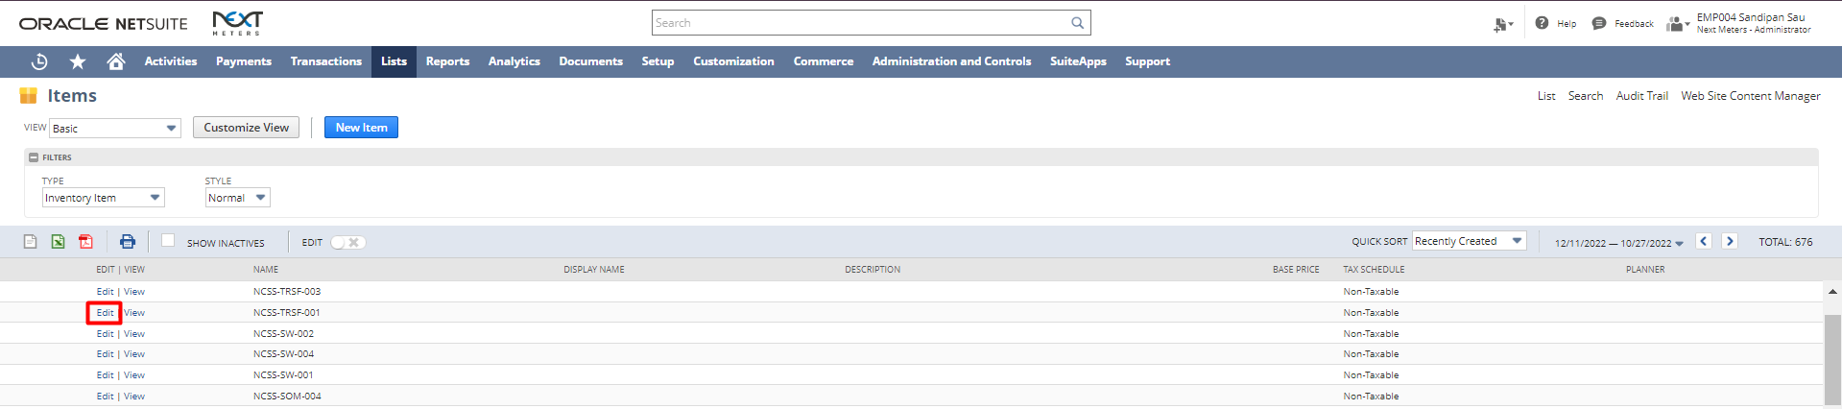

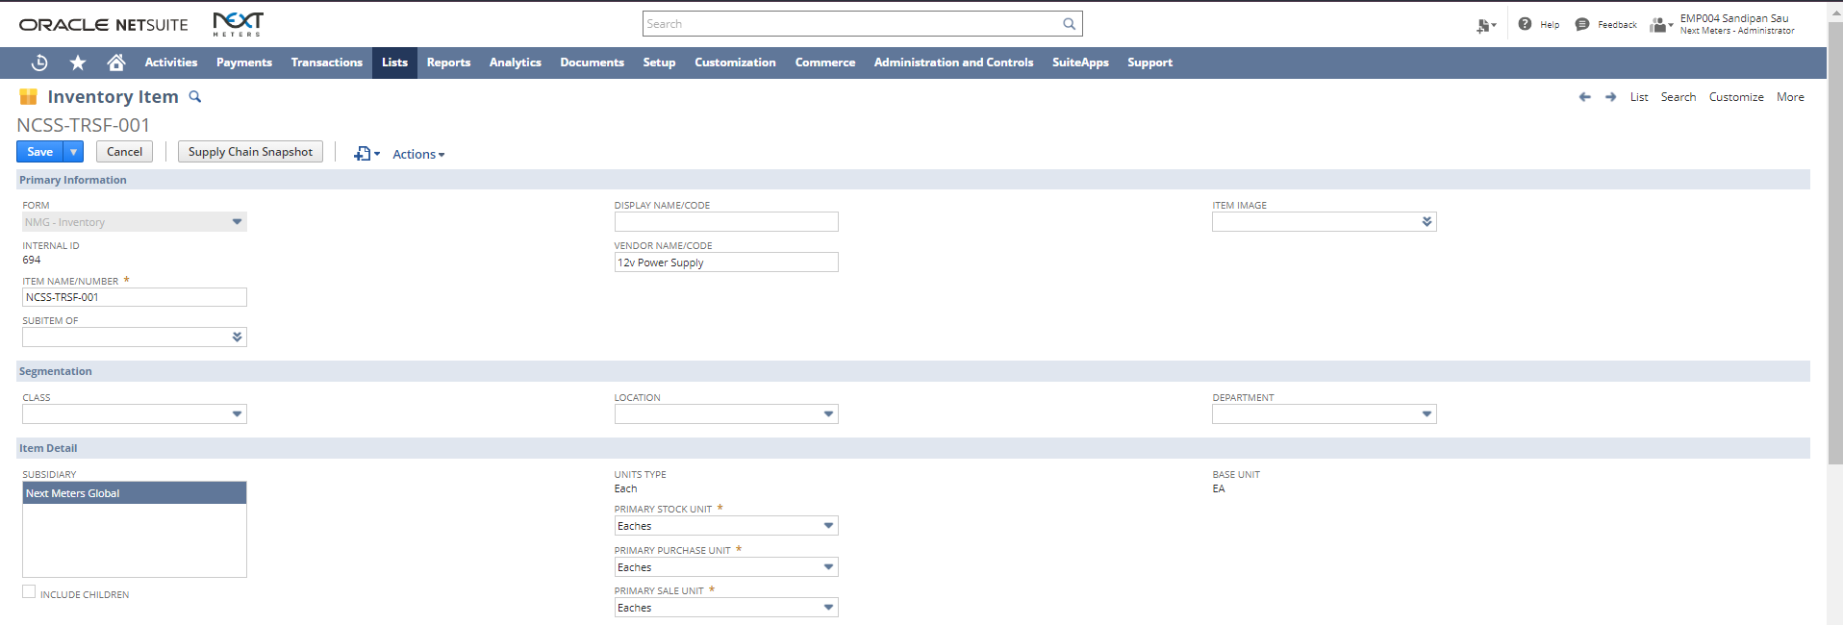
Under Purchasing/Inventory Sub-tab in sublist Inventory Management, Select Reorder Point in the field Replenishment Method and uncheck the Reorder Point Auto Calculate check box and click on Save.
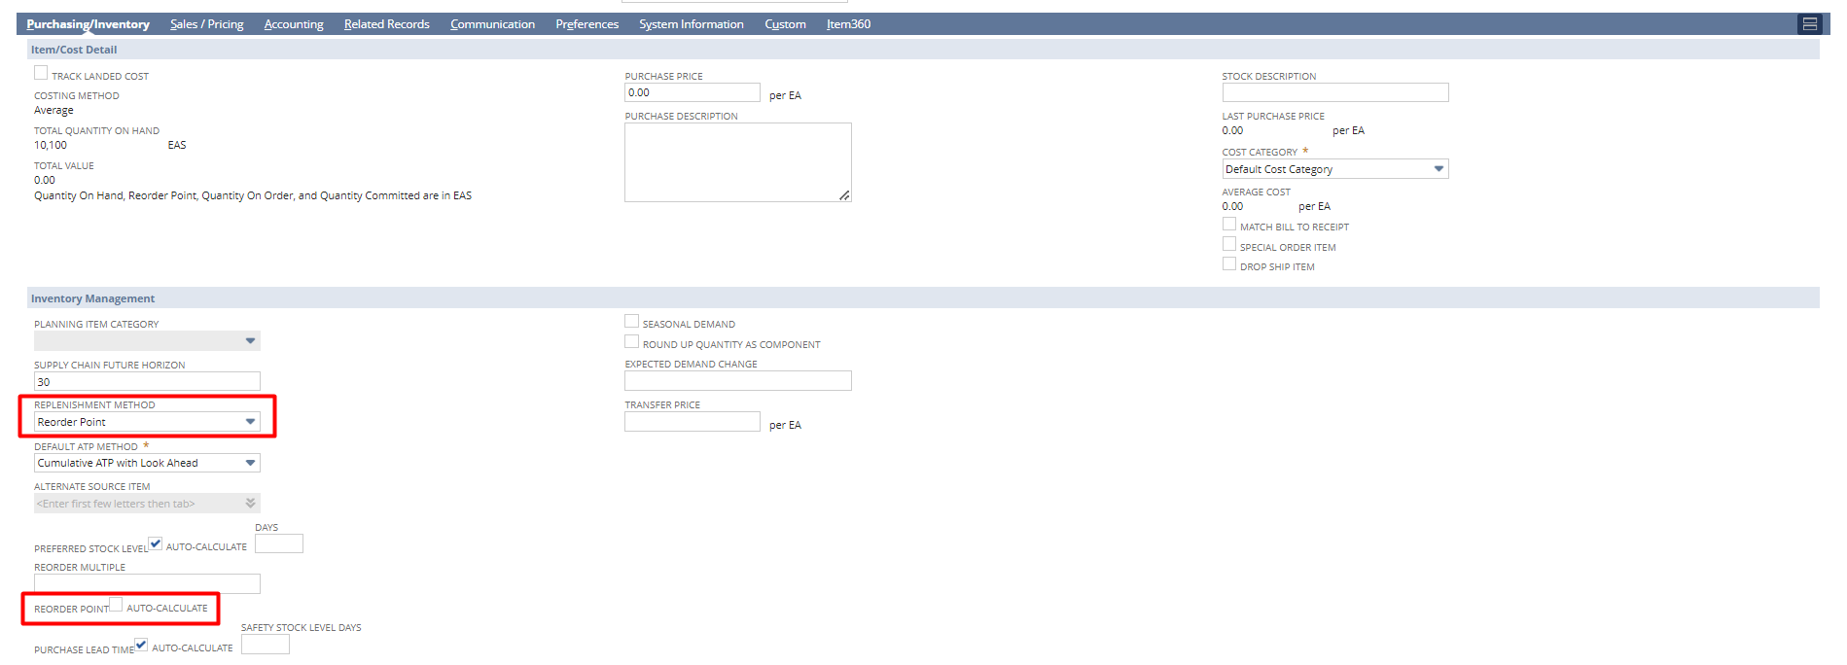
Again open the Item and under Purchasing/Inventory Sub-tab click on edit on Location and Select Reorder Point under the Planning tab and click on Save and Save the Item.
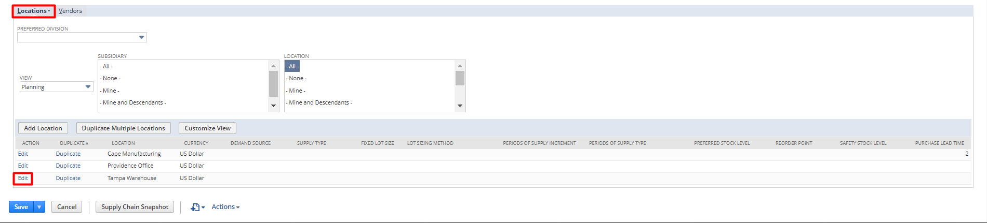
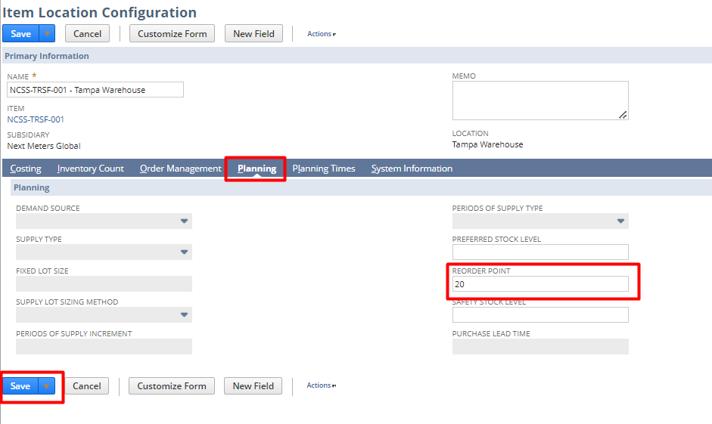
Build Point selection for Assembly Item:
Step 1: Item List: Navigate to Lists -> Accounting -> Items

We are taking the assembly item RE4 as an example here.
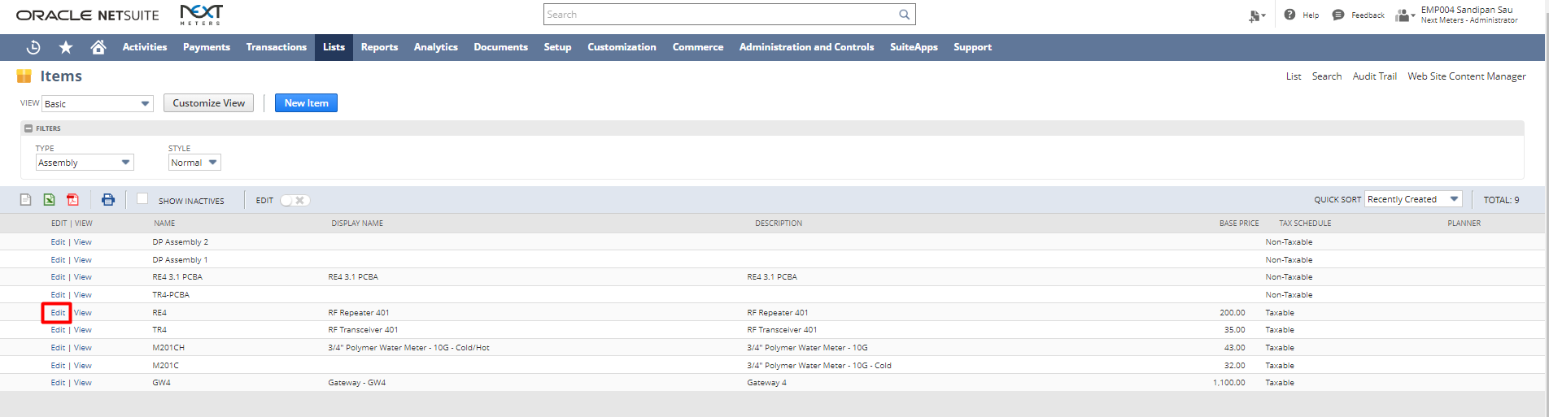
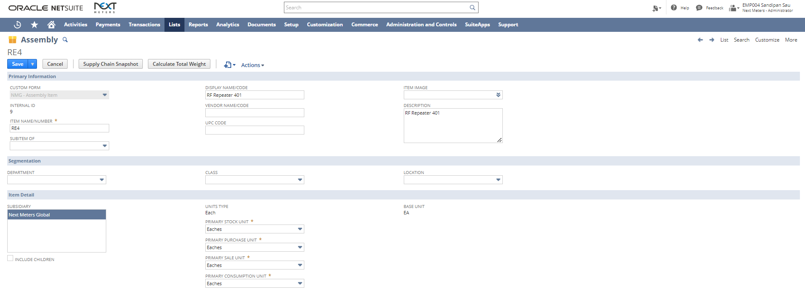
Under Purchasing/Inventory Sub-tab in sublist Inventory Management, Select Reorder Point in the field Replenishment Method and uncheck the Reorder Point Auto Calculate check box and click on Save.
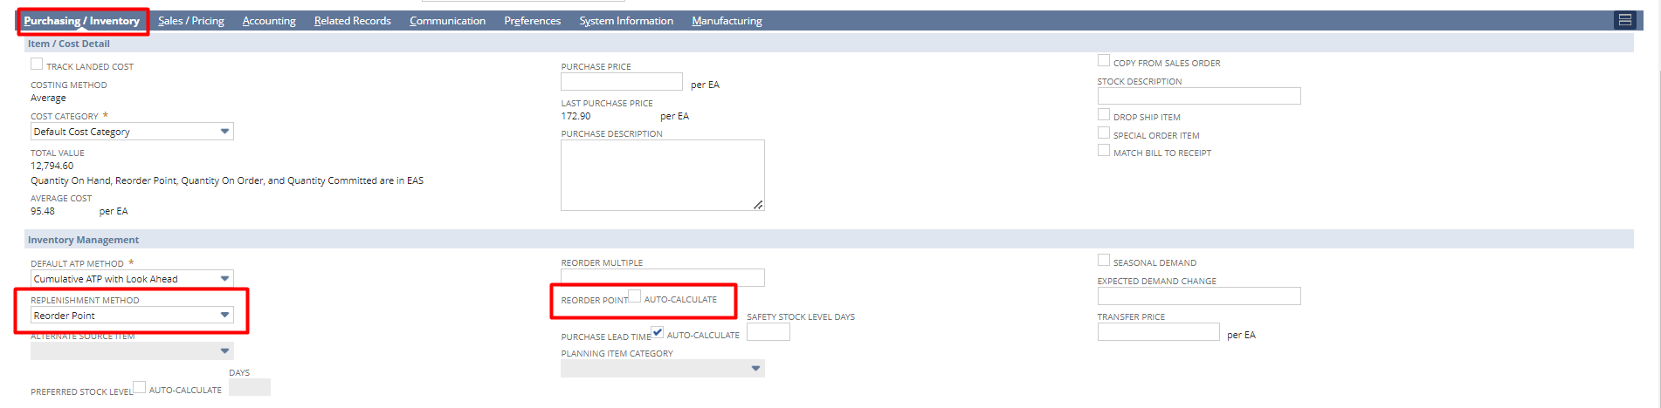
Again open the Item and under Purchasing/Inventory Sub-tab click on edit on Location and Select Reorder Point under the Planning tab and click on Save and Save the Item.
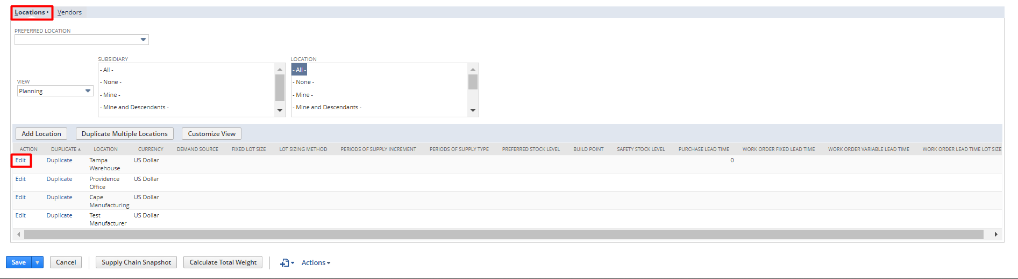
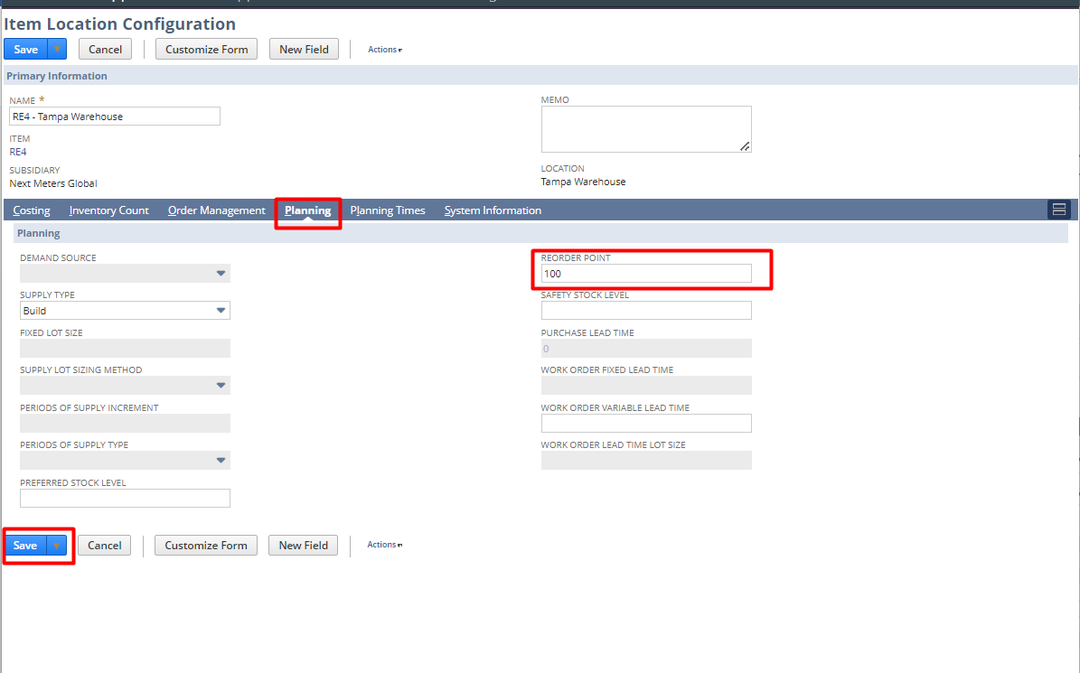
Sales Order Creation for Inventory Item:
Step 1: Inventory Item List: Navigate to Transactions -> Sales -> Enter Sales Order
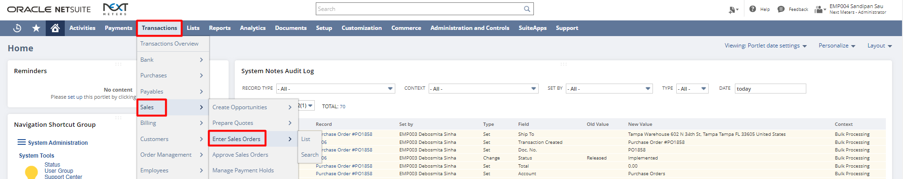
Fill in the required fields like Customer, Item and Item Quantity, etc.
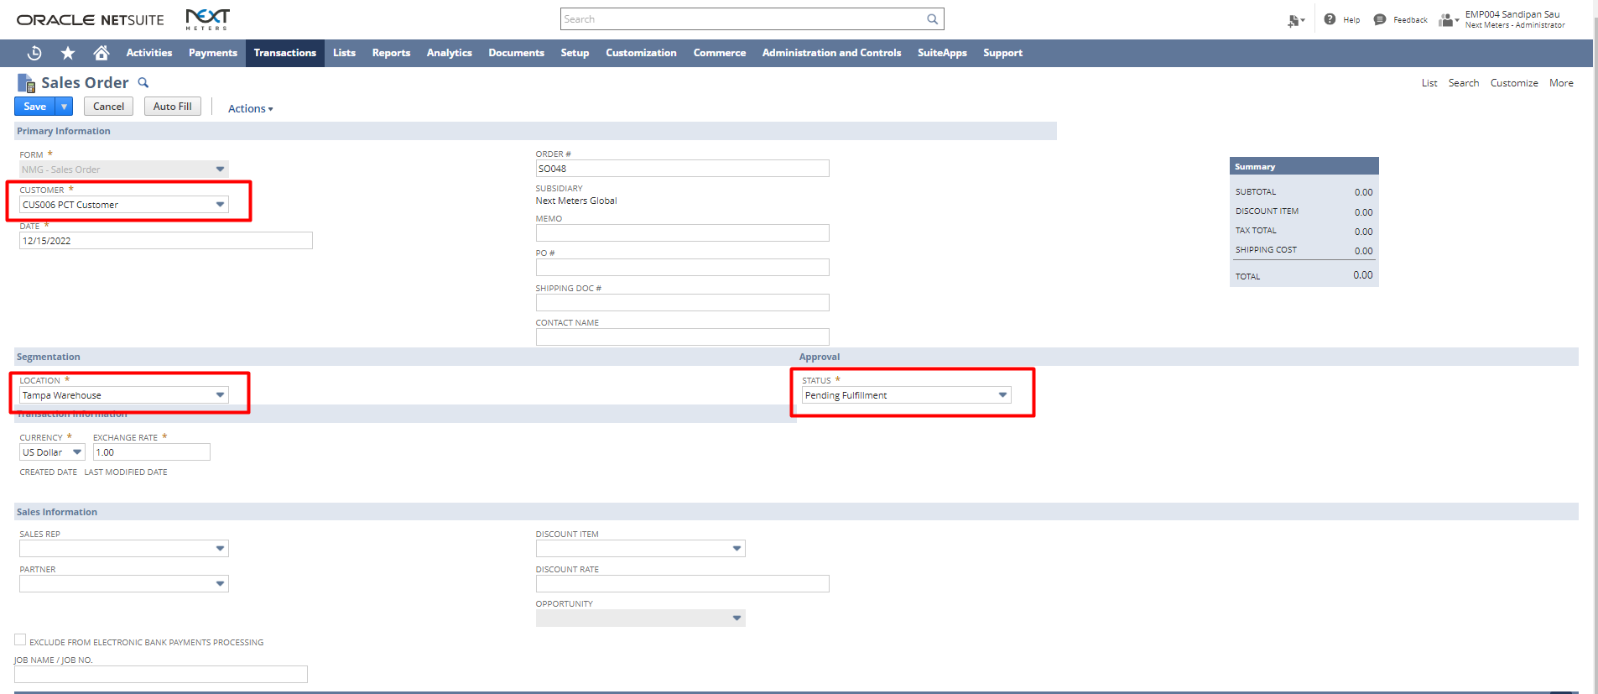

After adding the Item, Location, Quantity, etc. if the stock goes below the repoint stock quantity, a pop-up will come which will tell us to reorder the item.
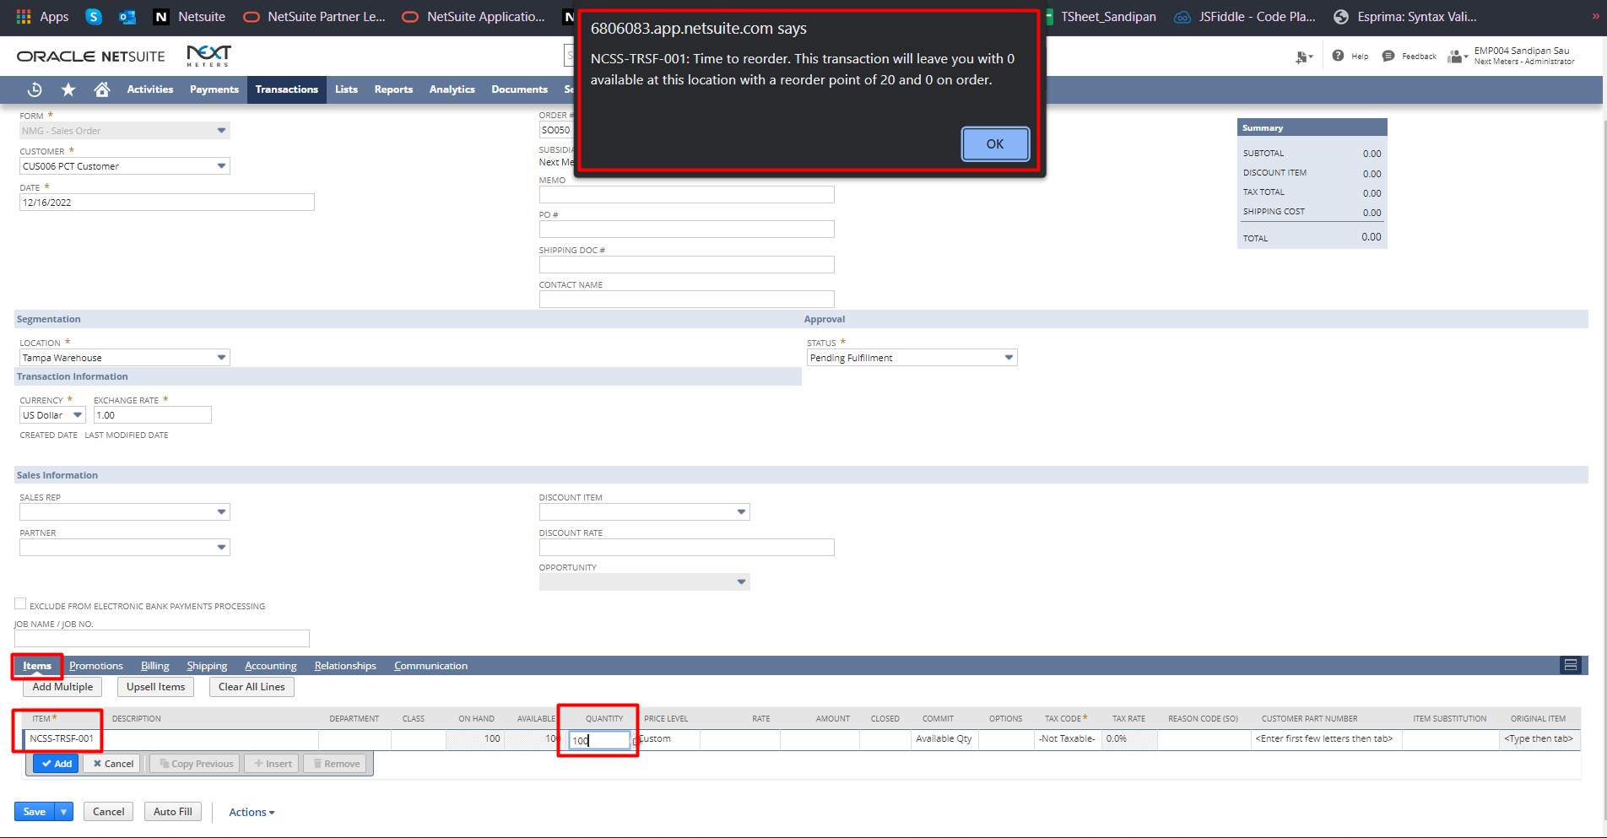
After filling in the details click on save.
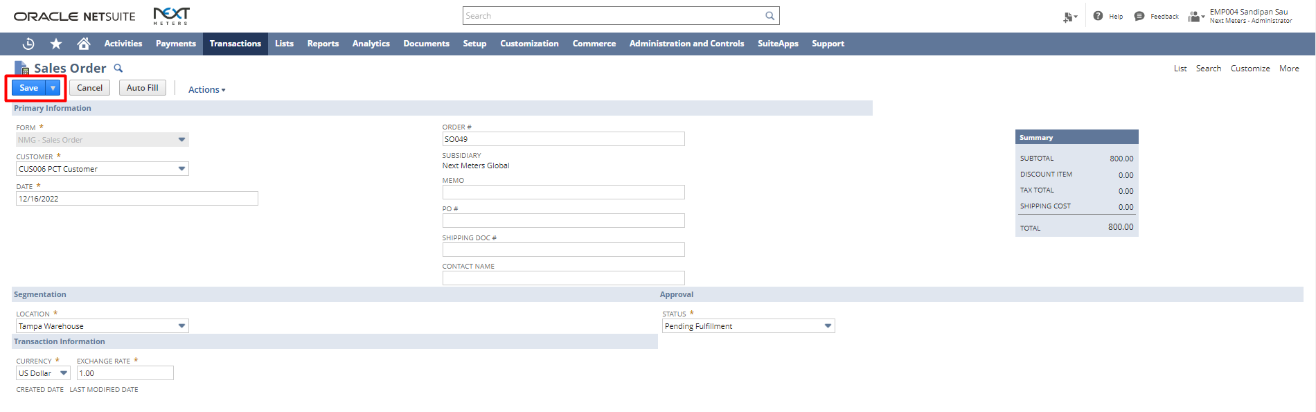

Order Items:
In Order to reorder the inventory item
Step 1: Order Items: Navigate to Transactions -> Inventory -> Order Items
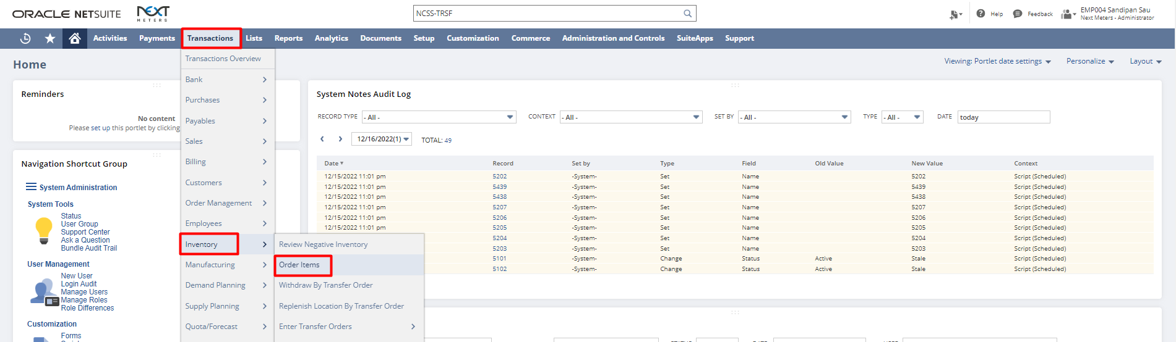
Under Reorder Point Items Select Vendor, Quantity, etc. and if the vendor is preferred for the selected item, then the vendor will be populated automatically.
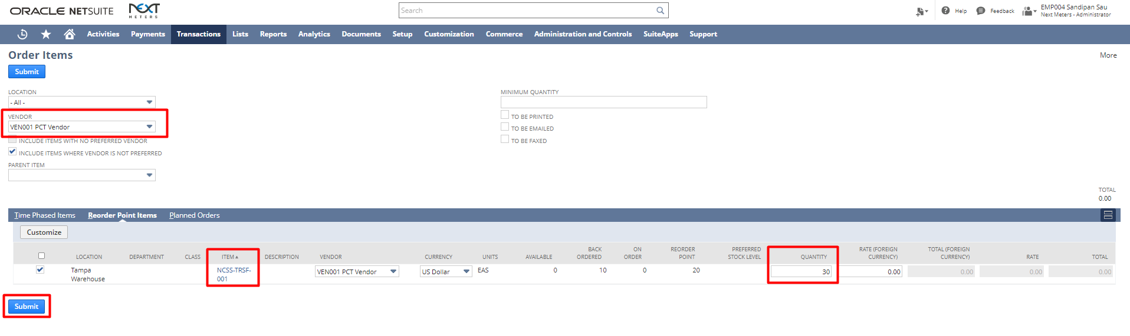
Step 2: Click on Submit to create the Purchase Order.
Sales Order Creation for Assembly Item:
Step 1: Navigate to Transactions -> Sales -> Enter Sales Order

Fill in the required fields like Customer, Item and Item Quantity, etc.

After adding the Item, Location, Quantity, etc. if the stock goes below the build point stock quantity, a pop-up will come which will tell us the availability of the item and that it has reached the Build point.
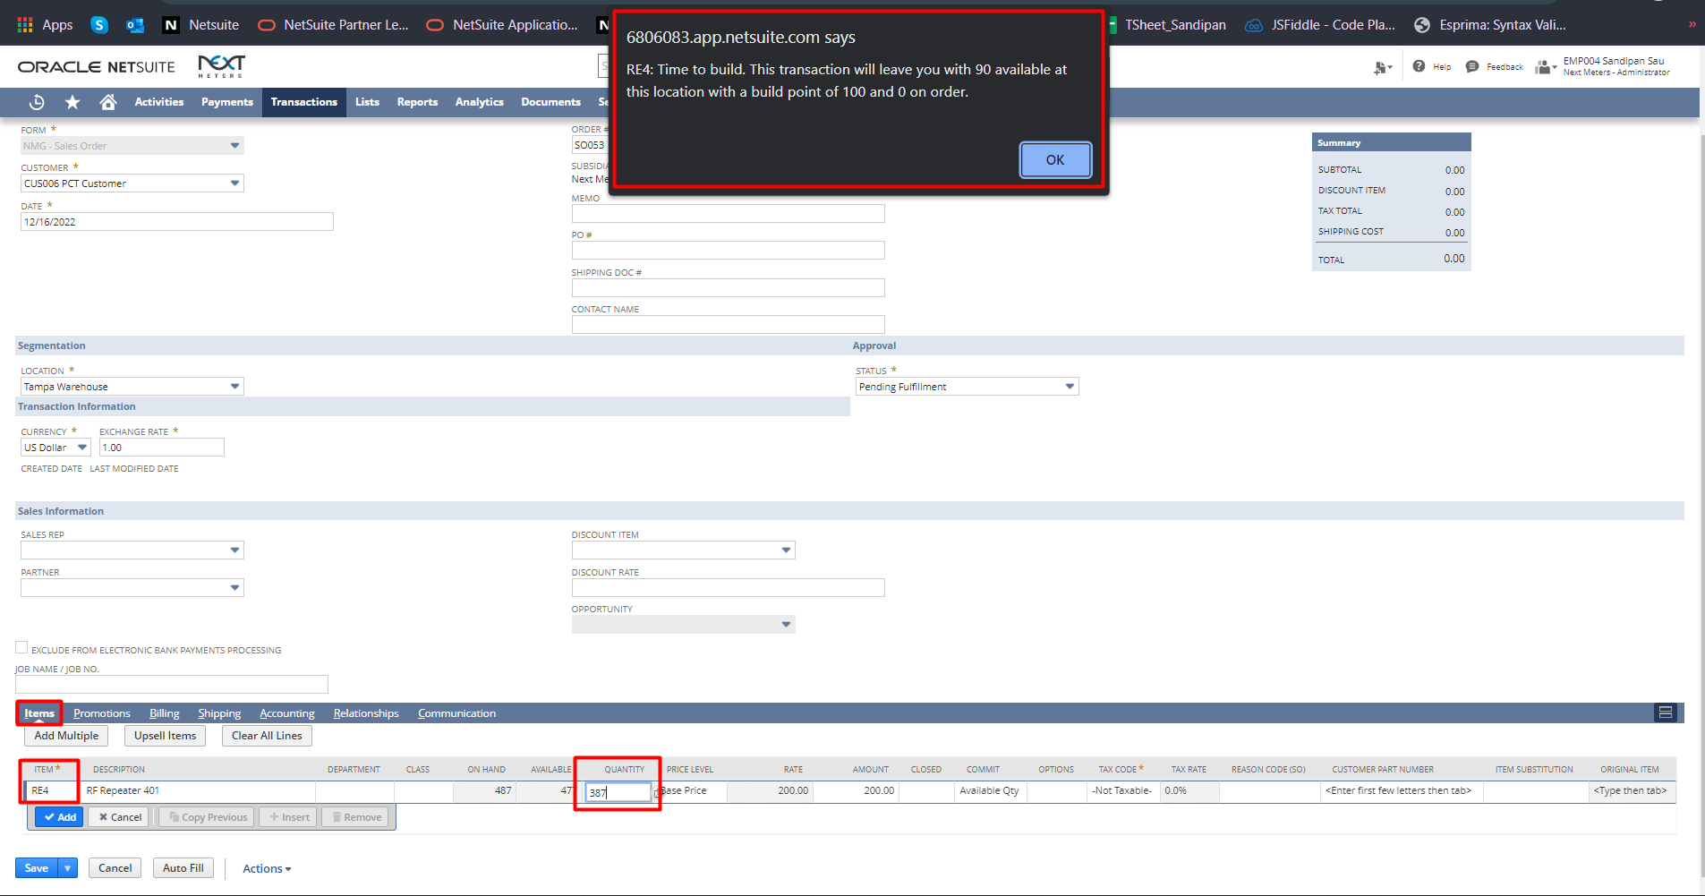
After filling in the details click on save.
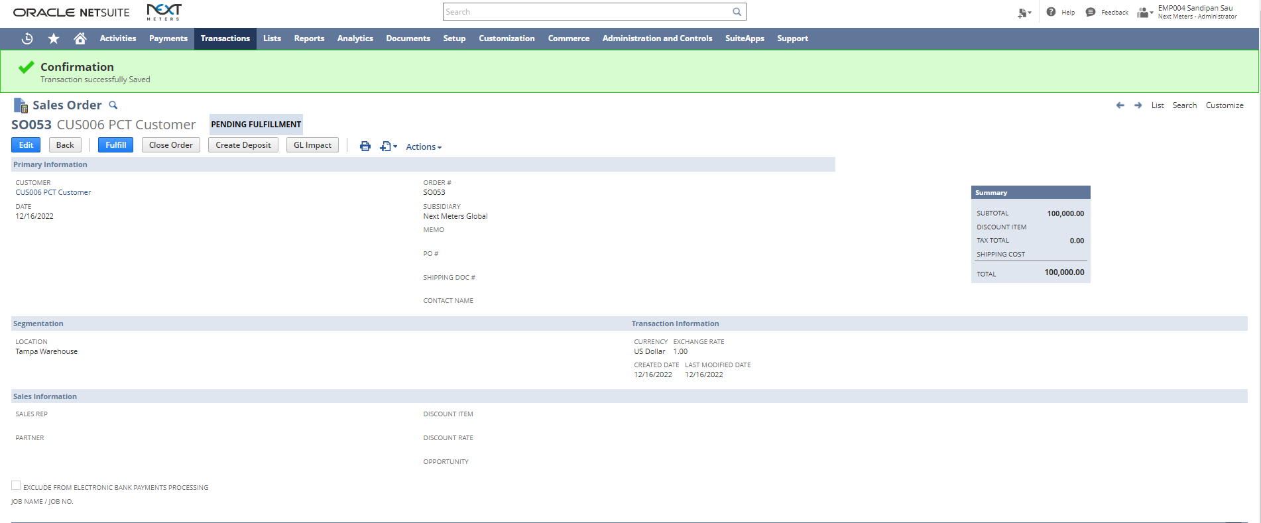
Mass Create Work Order
In order to rebuilt the Assembly Item
Step 1: Mass Create Work Order: Navigate to Transactions -> Supply Planning -> Mass Create Work Order
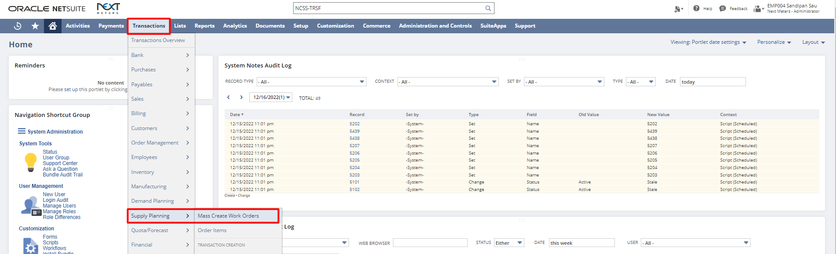
Under Reorder Point Items Select Quantity and check the checkbox.
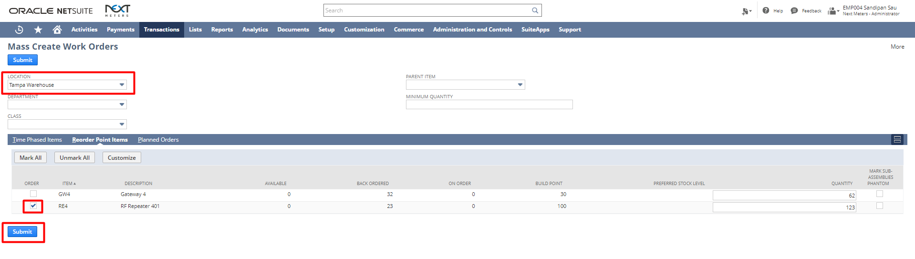
Step 2: Click on Submit to create the Work Order.

Signature:_____________________________ Date:______________________

Disclaimer:
Upon signing off on the process flow document, you are confirming that the process has been set up per the SOW within NetSuite per your business's needs. Any changes or modifications requested after sign-off will need to be a "change request" at an additional fee.

*** PLEASE ensure that you have logged into NetSuite and tested the process prior to signing off on the setup. Paapri requires sign-off on this document prior to moving forward with any additional design meetings.

